**PROMPT 1**

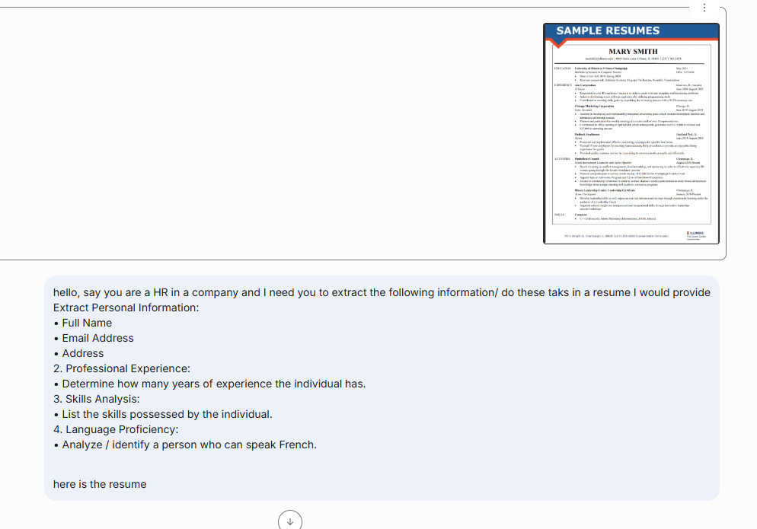

**PROMPT RESPONSE**  
As an HR representative, I have reviewed the resume you provided. Here is the extracted information and analysis you requested:

**1. Personal Information:**

* Full Name: Mary Smith
* Email Address: msmith2@illinois.edu
* Address: 4004 Helix Lane Urbana, IL 61801

**2. Professional Experience:**

Based on the roles listed, the individual has a total of 9 months of professional experience from the following positions:

* IT Intern at Aon Corporation (3 months: June 2020 - August 2020)
* Sales Assistant at Chicago Marketing Corporation (3 months: June 2019 - August 2019)
* Server at Outback Steakhouse (3 months: June 2018 - August 2018)

**3. Skills Analysis:**

The candidate lists the following computer skills:

* C++ (Advanced)
* Adobe Photoshop (Intermediate)
* HTML (Basic)

**4. Language Proficiency:**

After a complete review of the resume, there is **no mention of proficiency in the French language.**

**PROMPT 2**

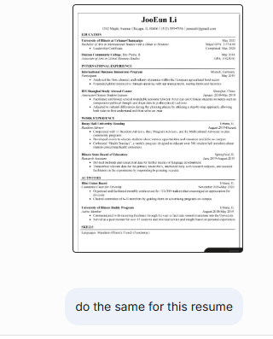

**PROMPT RESPONSE**

**1. Personal Information:**

* Full Name: JooEun Li
* Email Address: jooeunli@gmail.com
* Address: 1542 Maple Avenue Chicago, IL 60606

**2. Professional Experience:**

Based on the work experience listed, the individual has approximately 1 year of experience. This is calculated from the following roles:

* Resident Advisor at Busey Hall University Housing (August 2019 - Present, which is assumed to be at least through May 2020, the graduation date listed for her certificate).
* Research Assistant at Illinois State Board of Education (3 months: June 2019 - August 2019).

**3. Skills Analysis:**

The candidate's listed skills are focused on languages:

* Mandarin (Fluent)
* French (Functional)

**4. Language Proficiency:**

- **Yes**, **this individual can speak French.** Their proficiency level is listed as "Functional".

**PROMPT 3**

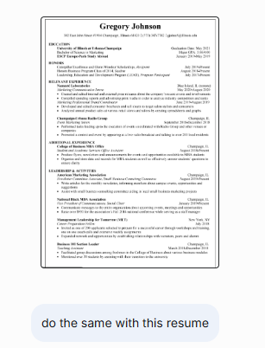

**PROMPT RESPONSE**

**1. Personal Information:**

* Full Name: Gregory Johnson
* Email Address: gjohns5@illinois.edu
* Address: 302 East John Street #1904 Champaign, Illinois 61820

**2. Professional Experience:**

Based on the "Relevant Experience" and "Additional Experience" sections, the individual has **approximately 2 years and 8 months of combined experience**. This is calculated from the following roles:

* Marketing Communication Intern at Namasté Laboratories (4 months: May 2020 - August 2020)
* Marketing Professional Brand Coordinator at Namasté Laboratories (3 months: June 2019 - August 2019)
* Event Marketing Intern at Champaign-Urbana Radio Group (4 months: September 2018 - December 2018)
* Student and Academic Services Office Assistant at College of Business MBA Office (August 2018 - Present, assumed to be at least until the resume was created)
* Teaching Assistant for Business 101 Section Leader (10 months: March 2018 - December 2018)

**3. Skills Analysis:**

This resume **does not include a dedicated "Skills" section**. However, based on the descriptions of the roles and responsibilities, **the following skills can be inferred:**

* Internal and External Communications
* Press Release Writing and Editing
* Data Analysis (spending reports, product sales)
* Event Coordination and Promotion
* Public Speaking and Broadcasting
* Content Creation (flyers, newsletters, announcements)
* Data Management
* Consulting
* Leadership and Mentoring

**4. Language Proficiency:**

After a thorough review, the resume **does not explicitly state any level of proficiency in the French** language. While the candidate participated in a "ESCP Europe-Paris Study Abroad" program, **this does not confirm their ability to speak French.**

**REFLECTION**

The activity was set up like a mock HR task where I had to review three different resumes and extract key details. I used the AI to act as an HR professional, since they’re typically the ones interviewing candidates and reviewing resumes, and to help me go through four main steps for each candidate:

* Get their basic personal info — full name, email, and physical address.
* Calculate their total work experience by looking at the timelines in their job history.
* Identify their skills — either from a dedicated “Skills” section or, if they didn’t list them all explicitly, infer them from their activities and experiences.
* Check if they had any French language ability.

I only had to give the AI the full set of instructions once. After that, I could simply say, “Do the same for this resume,” and it knew exactly what I meant, applying the same process without me having to repeat the details. I applied these steps to the resumes of Mary Smith, JooEun Li, and Gregory Johnson. In one case, the resume didn’t explicitly list all of the person’s skills, so the AI inferred likely skills by analyzing the roles they held and the tasks they performed. This consistent method made it easy to compare candidates and ensured that no required information was overlooked.

When it came to language skills, the result was clear: Gregory Johnson had studied abroad in Paris but didn’t actually claim to speak French, Mary Smith had no foreign languages listed, and only JooEun Li specifically mentioned French, stating her level as “Functional.”